Problem Area | Specific User Problem | Operational Consequence | Product Opportunity for Fleetsure
Trip Financial Visibility | Lack of a unified trip-level financial view due to fragmented tracking of revenue, fuel, FASTag, and other expenses | Margin leakage and inability to identify profitable routes, clients, or vehicles | Integrated trip P&L engine with automated cost capture and profitability analytics
Vehicle Maintenance Tracking | Absence of a centralized system to log servicing history, maintenance events, and repair costs | Increased breakdowns, unplanned downtime, and higher lifecycle maintenance expenses | Digital maintenance management suite with service logs, cost analytics, and preventive alerts
Document Management | Fleet documents stored across physical and digital silos without structured tracking or expiry monitoring | Compliance risks, penalty exposure, and operational delays during inspections | Centralized document vault with expiry tracking and compliance alert system
Tyre Lifecycle Tracking | No structured tracking of tyre inventory, installation position, rotation, or wear levels | Premature replacements, uneven wear, and inflated cost per kilometre | Tyre lifecycle intelligence system with position mapping and wear analytics
Spare Parts Tracking | Informal logging of spare part replacements and repair bills with no digitized audit trail | Poor visibility into true vehicle operating cost and vendor overcharging risks | Spare parts and repair tracking module with bill uploads and cost reporting
Workflow Automation | Heavy reliance on manual data entry and unstructured file sharing across WhatsApp and offline channels | Operational inefficiency, data inaccuracies, and delayed reporting cycles | Automation layer with WhatsApp bot ingestion, OCR, and auto-ledger updates

Pain Point Category | Frequency of Occurrence | Business Impact
Trip P&L Visibility | Daily | Very High
Maintenance Tracking | Weekly | Very High
Document Compliance | Monthly but critical | High
Workflow Automation | Daily | Very High
Tyre Lifecycle Tracking | Quarterly | Medium-High
Spare Parts Tracking | Event-based | Medium

Rank | Problem | Why It Matters Most
1 | Trip P&L visibility | Direct margin impact
2 | Maintenance tracking | Downtime + repair cost
3 | Document compliance | Legal & operational risk
4 | Workflow automation | Adoption + scale enabler
5 | Tyre lifecycle | Asset cost optimization
6 | Spare parts tracking | Cost leakage control

DATA link
We calculated this with the help of data we had of previous trips by the tank trucks
Component | Amount (INR) | % of Total Fare
Gross Fare (Revenue) | ₹68,100 | 100%
Fuel Expense | ₹34,030 | 50.0%
Toll Expense | ₹8,810 | 12.9%
Cash/Driver Misc. | ₹2,000 | 2.9%
Maintenance & Tyres (Est.) | ₹4,080 | 6.0%
Insurance & Fixed Overheads (Est.) | ₹4,760 | 7.0%
Total Operating Expense | ₹53,680 | 78.8%
--- | --- | ---
Net Profit per Trip | ₹14,420 | 21.2%

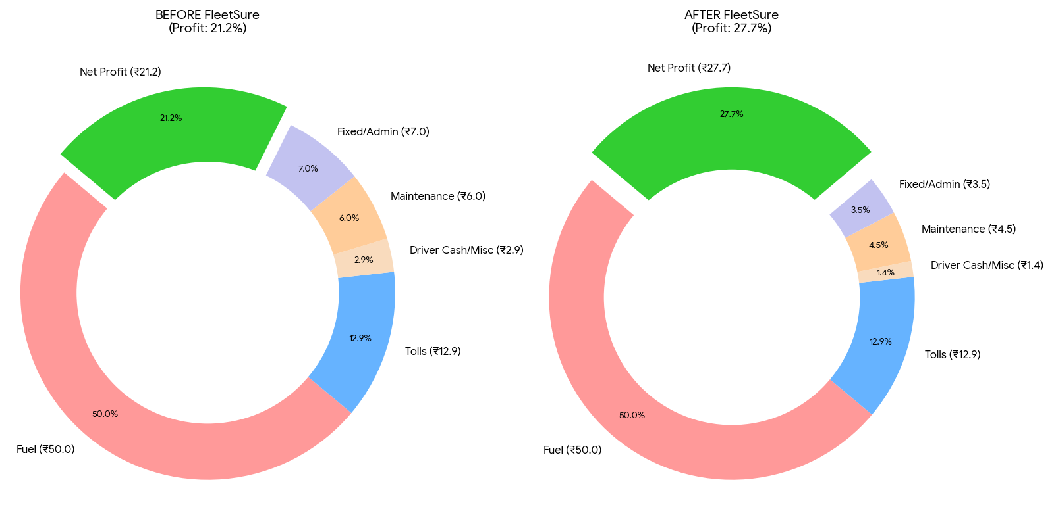

Margin improvement by 6.5% can reflect big with the fleet size as maintenance and driver cash are the most unaccounted cost and repetitive mentioned by the users. Working on fuel and FASTag components is difficult In the current scenario as fixed diesel per route and fixed route is practiced in LPG segment.

